# 2009 Observing Notes

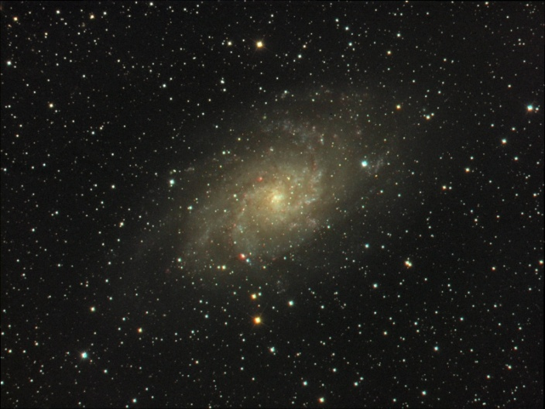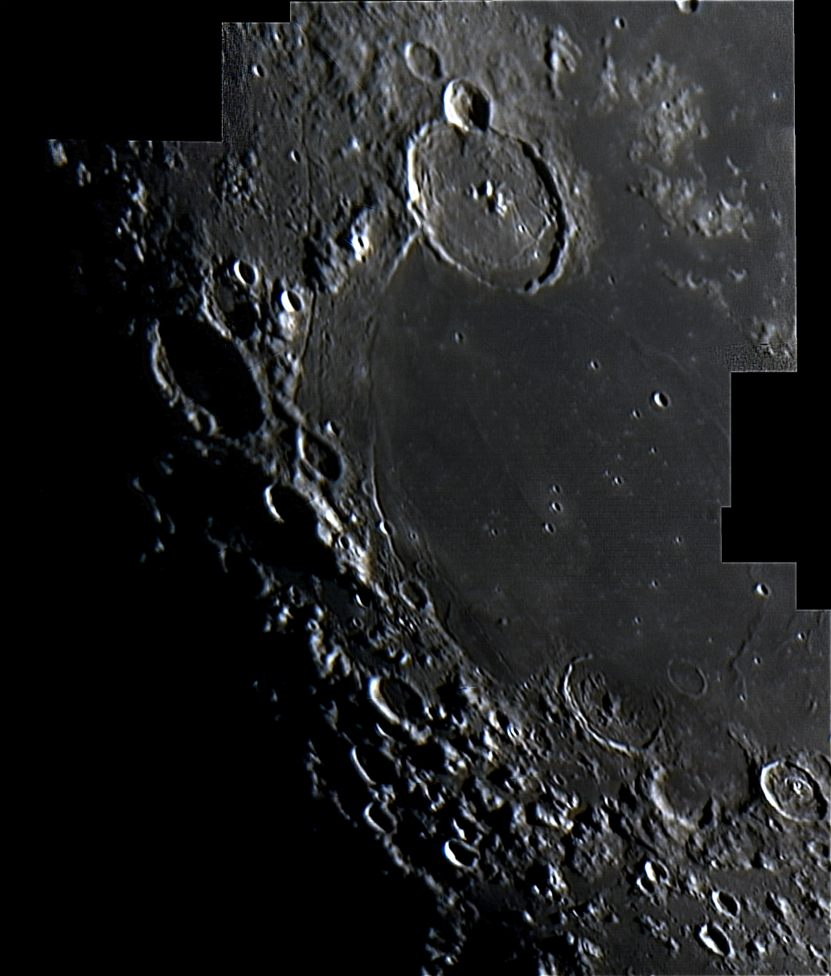

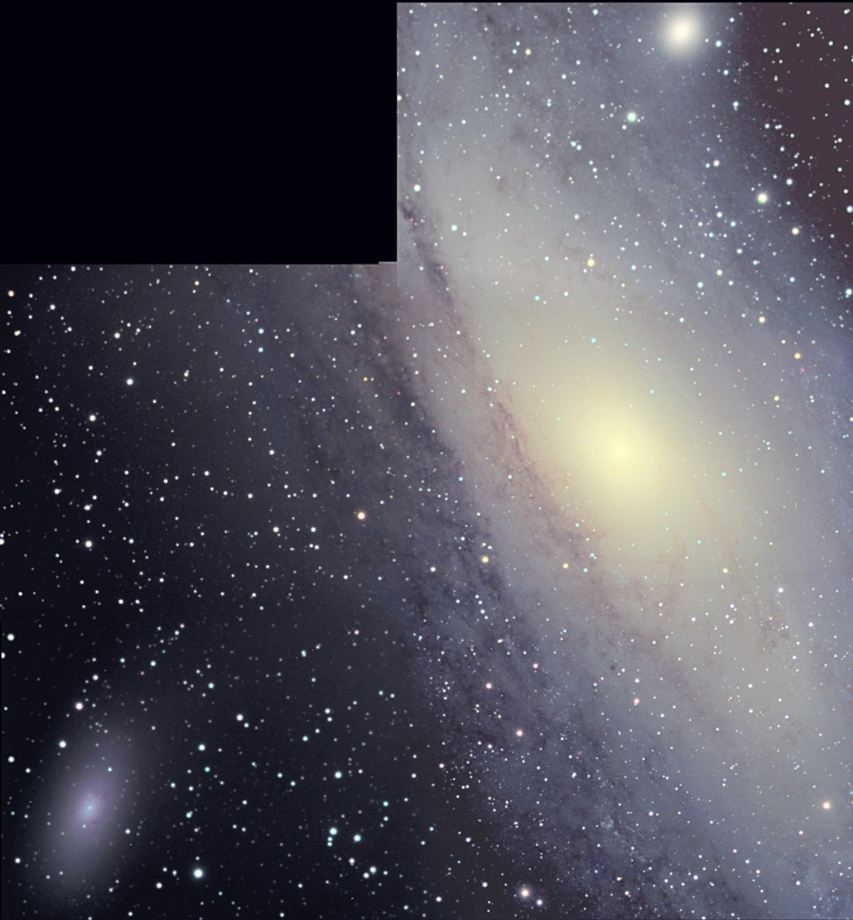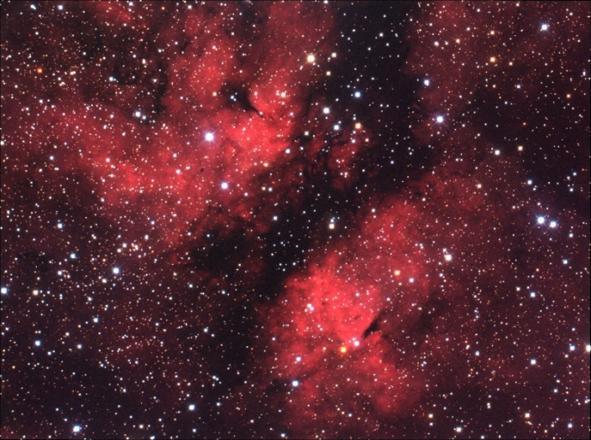

**No idea what picture this is!**

[2009 Observing Notes 1](#_Toc467235477)

[Year in Review 3](#_Toc467235478)

[January 4](#_Toc467235479)

[2009-Jan-17 (Jan-18 UT): M33 LRGB 4](#_Toc467235480)

[August 6](#_Toc467235481)

[2009-Aug-20 (Aug-21 UT): IC 1318 Butterfly Nebula – RGB Imaging 6](#_Toc467235482)

[September 8](#_Toc467235483)

[2009-Sep-26 (Sep-27 UT): Jupiter and Eastern Imbrium 8](#_Toc467235484)

[2009-Sep-29 (Sep-30 UT): Io Occulting Europa, including Jupiter 10](#_Toc467235485)

[November 13](#_Toc467235486)

[2009-Nov-22 (Nov-23 UT): New M31 Mosaic Images 13](#_Toc467235487)

[Appendices 14](#_Toc467235488)

[Jupiter Analysis 2009 Apparition 14](#_Toc467235489)

## Year in Review

Reconstructing old observations, particularly recovering a bunch that were almost lost.

## January

### 2009-Jan-17 (Jan-18 UT): M33 LRGB

Last Updated 11/17/2016

Below are images created using data processed in 2009, but aligned and stacked in 2016 using MaximDL.

|  |  |
| --- | --- |
| F:\Astronomy\Projects\Galaxies\M33\Imaging Data\20090118UT\M33-20090118UT-RED-sum0h45m-Flattened-Log-HalfSize.jpg | F:\Astronomy\Projects\Galaxies\M33\Imaging Data\20090118UT\M33-20090118UT-GRN-sum0h15m-Flattened-Log-HalfSize.jpg |
| M33-20090118UT-RED-sum0h45m-Flattened-Log-HalfSize.jpg | M33-20090118UT-GRN-sum0h15m-Flattened-Log-HalfSize.jpg |
| F:\Astronomy\Projects\Galaxies\M33\Imaging Data\20090118UT\M33-20090118UT-BLU-sum0h15m-Flattened-Log-HalfSize.jpg | F:\Astronomy\Projects\Galaxies\M33\Imaging Data\20090118UT\M33-20090118UT-CLR-sum0h35m-Flattened-Log-HalfSize.jpg |
| M33-20090118UT-BLU-sum0h15m-Flattened-Log-HalfSize.jpg | M33-20090118UT-CLR-sum0h35m-Flattened-Log-HalfSize.jpg |

|  |
| --- |
| F:\Astronomy\Projects\Galaxies\M33\Imaging Data\20090118UT\M33-20090118UT-LRGB-ColBal-Sat200pct-HalfSize.jpg |
| M33-20090118UT-BLU-sum0h15m-Flattened-Log-HalfSize.jpg |

**Data Disposition:** Raw data zipped on 500GB archive drive. Processed data resides on the Astrothumb2 thumb drive.

## August

### 2009-Aug-20 (Aug-21 UT): IC 1318 Butterfly Nebula – RGB Imaging

Last Updated 11/18/2016

Below are images created using data processed in 2009, but aligned and stacked in 2016 using MaximDL.

|  |  |
| --- | --- |
| F:\Astronomy\Projects\Nebulae-Diffuse\IC1318 - Butterfly\Imaging Data\20090820UT\Butterfly-20090820UT-RED-sum0h35m-Flattened-Log-HalfSize.jpg | F:\Astronomy\Projects\Nebulae-Diffuse\IC1318 - Butterfly\Imaging Data\20090820UT\Butterfly-20090820UT-GRN-sum0h15m-Flattened-Log-HalfSize.jpg |
| Butterfly-20090820UT-RED-sum0h35m-Flattened-Log-HalfSize.jpg | Butterfly-20090820UT-GRN-sum0h15m-Flattened-Log-HalfSize.jpg |
| F:\Astronomy\Projects\Nebulae-Diffuse\IC1318 - Butterfly\Imaging Data\20090820UT\Butterfly-20090820UT-BLU-sum0h15m-Flattened-Log-HalfSize.jpg | F:\Astronomy\Projects\Nebulae-Diffuse\IC1318 - Butterfly\Imaging Data\20090820UT\Butterfly-20090820UT-R+G+B-sum1h05m-Flattened-Log-HalfSize.jpg |
| Butterfly-20090820UT-BLU-sum0h15m-Flattened-Log-HalfSize.jpg | Butterfly-20090820UT-R+G+B-sum1h05m-Flattened-Log-HalfSize.jpg |

|  |
| --- |
| F:\Astronomy\Projects\Nebulae-Diffuse\IC1318 - Butterfly\Imaging Data\20090820UT\Butterfly-20090820UT-sLRGB_sat120pct-HalfSize.jpg |
| Butterfly-20090820UT-sLRGB\_sat120pct-HalfSize.jpg |

## September

### 2009-Sep-26 (Sep-27 UT): Jupiter and Eastern Imbrium

Last Updated 1/18/2015

I took a two-frame mosaic of eastern Imbrium, each with two 60-second videos with the C8 at 2000mm (f/10) and the ToUcam. I also took 2x1min video with C8 at 2000mm (f/10) and ToUcam. Io, Europa and Callisto are visible.

|  |
| --- |
| G:\Astronomy\Data\2009\09\26\EasternImbrium_2000mm_60sec_Setttings1__Mosaic-Wavelets.jpg |
| EasternImbrium\_2000mm\_60sec\_Setttings1\_\_Mosaic-Wavelets.jpg |
| D:\Astronomy\Data\2009\09\26\JPMNSLVAS.JPG |
| JPMNSLVAS.JPG |

Volume in drive F is My Book

Volume Serial Number is 3D98-140F

Directory of F:\Astronomy\VideoAstronomyData\20090926

09/26/2009 09:41 PM 830,917,120 EasternImbrium\_2000mm\_60sec\_Setttings1\_\_0000.avi

09/26/2009 09:44 PM 830,455,808 EasternImbrium\_2000mm\_60sec\_Setttings1\_\_0001.avi

09/26/2009 09:46 PM 829,533,184 EasternImbrium\_2000mm\_60sec\_Setttings1\_\_0002.avi

09/26/2009 09:47 PM 822,152,192 EasternImbrium\_2000mm\_60sec\_Setttings1\_\_0003.avi

09/26/2009 09:50 PM 136,157,184 EasternImbriumDark\_2000mm\_10sec\_Setttings1\_\_0000.avi

09/26/2009 10:44 PM 828,610,560 Jupiter\_2000mm\_60sec\_Setttings2\_\_0000.avi

09/26/2009 10:45 PM 817,539,072 Jupiter\_2000mm\_60sec\_Setttings2\_\_0001.avi

09/26/2009 10:46 PM 135,695,872 Jupiter\_2000mm\_Dark\_10sec\_Setttings2\_\_0000.avi

8 File(s) 5,231,060,992 bytes

0 Dir(s) 90,612,334,592 bytes free

**Data Disposition:** These data were recovered after an accidental deletion of files on the Astronomy laptop. As of 5/4/2015, processed data are in the /data directory on the thumb drive and need to be moved to the /images directory on the Astronomy laptop. The raw data have been zipped on the thumb drive and are ready to be moved to the 2TB archive drive.

### 2009-Sep-29 (Sep-30 UT): Io Occulting Europa, including Jupiter

Last Updated 4/7/2017

It appears that much of the raw data were lost for this set of observations. I have recovered ZIP files for the videos for a subset (need to document).

|  |  |  |  |
| --- | --- | --- | --- |
| G:\Astronomy\Data\2009\09\29LT\Jupiter_60sec_1108thru1112_4frames_WaveletsJupiter5-StrIoOccEurCrop.jpg | G:\Astronomy\Data\2009\09\29LT\Jupiter_60sec_1114thru1117_4frames_WaveletsJupiter5-StrIoOccEurCrop.jpg | G:\Astronomy\Data\2009\09\29LT\Jupiter_60sec_1118thru1122_4frames_WaveletsJupiter5-StrIoOccEurCrop.jpg | G:\Astronomy\Data\2009\09\29LT\Jupiter_60sec_1123thru1126_5frames_WaveletsJupiter5-StrIoOccEurCrop.jpg |
| Jupiter\_60sec\_1108thru1112\_4frames\_WaveletsJupiter5-StrIoOccEurCrop.jpg | Jupiter\_60sec\_1114thru1117\_4frames\_WaveletsJupiter5-StrIoOccEurCrop.jpg | Jupiter\_60sec\_1118thru1122\_4frames\_WaveletsJupiter5-StrIoOccEurCrop.jpg | Jupiter\_60sec\_1123thru1126\_5frames\_WaveletsJupiter5-StrIoOccEurCrop.jpg |
| G:\Astronomy\Data\2009\09\29LT\Jupiter_60sec_1127thru1131_5frames_WaveletsJupiter5-StrIoOccEurCrop.jpg | G:\Astronomy\Data\2009\09\29LT\Jupiter_60sec_1139thru1143_4frames_WaveletsJupiter5-StrIoOccEurCrop.jpg | G:\Astronomy\Data\2009\09\29LT\Jupiter_60sec_1148thru1152_4frames_WaveletsJupiter5-StrIoOccEurCrop.jpg | F:\Astronomy\Projects\Planets\Jupiter\Imaging Data\20090930UT\Jupiter_60sec_1059thru1102_4frames_WaveletsJupiter4-StrIoOccEurCrop.jpg |
| Jupiter\_60sec\_1127thru1131\_5frames\_WaveletsJupiter5-StrIoOccEurCrop.jpg | Jupiter\_60sec\_1139thru1143\_4frames\_WaveletsJupiter5-StrIoOccEurCrop.jpg | Jupiter\_60sec\_1148thru1152\_4frames\_WaveletsJupiter5-StrIoOccEurCrop.jpg | Jupiter\_60sec\_1059thru1102\_4frames\_WaveletsJupiter4-StrIoOccEurCrop.jpg |

Why is there so much variation in resolution? Could it be that the other images were aligned using Jupiter rather than the moons themselves?

|  |  |  |  |  |  |  |  |  |  |  |  |  |  |  |  |  |  |  |  |
| --- | --- | --- | --- | --- | --- | --- | --- | --- | --- | --- | --- | --- | --- | --- | --- | --- | --- | --- | --- |
| **Date (UT)** | **Size** | **Mag.** | **mag/as2** | **CM I** | **CM II** | **CM III** | **Jupiter** | **GRS** | **Io** | **Europa** | **Ganymede** | **Callisto** | **Himalia** | **Elevation** | **Seeing** | **Visual** | **Photo** | **Comments** | **Update** |
| 2009-Sep-30 05:01 |  |  |  |  |  |  | X |  | X | X |  |  |  |  |  | 0 | 1 | Imaging: Took 4x1min videos of Jupiter and eclipsing moons with C8 at 5500mm (f/27.5) and ToUcam. CHECK TIMES AND NUMBER OF VIDEOS. | 2010-Dec-16 |
| 2009-Sep-30 05:10 |  |  |  |  |  |  | X |  | X | X |  |  |  |  |  | 0 | 1 | Imaging: Took 4x1min videos of Jupiter and eclipsing moons with C8 at 5500mm (f/27.5) and ToUcam. CHECK TIMES AND NUMBER OF VIDEOS. | 2010-Dec-16 |
| 2009-Sep-30 05:16 |  |  |  |  |  |  | X |  | X | X |  |  |  |  |  | 0 | 1 | Imaging: Took 4x1min videos of Jupiter and eclipsing moons with C8 at 5500mm (f/27.5) and ToUcam. CHECK TIMES AND NUMBER OF VIDEOS. | 2010-Dec-16 |
| 2009-Sep-30 05:22 |  |  |  |  |  |  | X |  | X | X |  |  |  |  |  | 0 | 1 | Imaging: Took 4x1min videos of Jupiter and eclipsing moons with C8 at 5500mm (f/27.5) and ToUcam. CHECK TIMES AND NUMBER OF VIDEOS. | 2010-Dec-16 |
| 2009-Sep-30 05:26 |  |  |  |  |  |  | X |  | X | X |  |  |  |  |  | 0 | 1 | Imaging: Took 4x1min videos of Jupiter and eclipsing moons with C8 at 5500mm (f/27.5) and ToUcam. CHECK TIMES AND NUMBER OF VIDEOS. | 2010-Dec-16 |
| 2009-Sep-30 05:30 |  |  |  |  |  |  | X |  | X | X |  |  |  |  |  | 0 | 1 | Imaging: Took 4x1min videos of Jupiter and eclipsing moons with C8 at 5500mm (f/27.5) and ToUcam. CHECK TIMES AND NUMBER OF VIDEOS. | 2010-Dec-16 |
| 2009-Sep-30 05:41 |  |  |  |  |  |  | X |  | X | X |  |  |  |  |  | 0 | 1 | Imaging: Took 4x1min videos of Jupiter and eclipsing moons with C8 at 5500mm (f/27.5) and ToUcam. CHECK TIMES AND NUMBER OF VIDEOS. | 2010-Dec-16 |
| 2009-Sep-30 05:50 |  |  |  |  |  |  | X |  | X | X |  |  |  |  |  | 0 | 1 | Imaging: Took 4x1min videos of Jupiter and eclipsing moons with C8 at 5500mm (f/27.5) and ToUcam. CHECK TIMES AND NUMBER OF VIDEOS. | 2010-Dec-16 |

Video file listing from 20090929\_VideoTimes.txt:

Volume in drive F is My Book

Volume Serial Number is 3D98-140F

Directory of F:\Astronomy\VideoAstronomyData\20090929

09/29/2009 10:17 PM 825,381,376 Gassendi\_60sec\_Setttings1\_\_0000.avi

09/29/2009 10:19 PM 829,533,184 Gassendi\_60sec\_Setttings1\_\_0001.avi

09/29/2009 10:20 PM 827,687,936 Gassendi\_60sec\_Setttings1\_\_0002.avi

09/29/2009 10:21 PM 821,690,880 Gassendi\_60sec\_Setttings1\_\_0003.avi

09/29/2009 10:30 PM 134,773,248 GassendiDark\_10sec\_Setttings1\_\_0000.avi

09/29/2009 10:31 PM 134,773,248 GassendiFlat\_10sec\_Setttings1\_\_0000.avi

09/29/2009 10:59 PM 821,690,880 Jupiter\_60sec\_Setttings2\_\_0000.avi

09/29/2009 11:00 PM 807,390,208 Jupiter\_60sec\_Setttings2\_\_0001.avi

09/29/2009 11:01 PM 800,009,216 Jupiter\_60sec\_Setttings2\_\_0002.avi

09/29/2009 11:02 PM 782,940,672 Jupiter\_60sec\_Setttings2\_\_0003.avi

09/29/2009 11:08 PM 775,559,680 Jupiter\_60sec\_Setttings2\_\_0004.avi

09/29/2009 11:09 PM 762,642,944 Jupiter\_60sec\_Setttings2\_\_0005.avi

09/29/2009 11:10 PM 775,559,680 Jupiter\_60sec\_Setttings2\_\_0006.avi

09/29/2009 11:11 PM 765,872,128 Jupiter\_60sec\_Setttings2\_\_0007.avi

09/29/2009 11:14 PM 765,410,816 Jupiter\_60sec\_Setttings2\_\_0008.avi

09/29/2009 11:15 PM 772,330,496 Jupiter\_60sec\_Setttings2\_\_0009.avi

09/29/2009 11:16 PM 780,634,112 Jupiter\_60sec\_Setttings2\_\_0010.avi

09/29/2009 11:17 PM 788,015,104 Jupiter\_60sec\_Setttings2\_\_0011.avi

ARCHIVED:

09/29/2009 11:18 PM 768,178,688 Jupiter\_60sec\_Setttings2\_\_0012.avi

09/29/2009 11:19 PM 775,559,680 Jupiter\_60sec\_Setttings2\_\_0013.avi

09/29/2009 11:21 PM 773,253,120 Jupiter\_60sec\_Setttings2\_\_0014.avi

09/29/2009 11:22 PM 770,023,936 Jupiter\_60sec\_Setttings2\_\_0015.avi

09/29/2009 11:23 PM 744,190,464 Jupiter\_60sec\_Setttings2\_\_0016.avi

09/29/2009 11:24 PM 741,883,904 Jupiter\_60sec\_Setttings2\_\_0017.avi

09/29/2009 11:25 PM 759,875,072 Jupiter\_60sec\_Setttings2\_\_0018.avi

09/29/2009 11:26 PM 758,952,448 Jupiter\_60sec\_Setttings2\_\_0019.avi

ARCHIVED:

09/29/2009 11:27 PM 771,407,872 Jupiter\_60sec\_Setttings2\_\_0020.avi

09/29/2009 11:28 PM 782,940,672 Jupiter\_60sec\_Setttings2\_\_0021.avi

09/29/2009 11:30 PM 755,723,264 Jupiter\_60sec\_Setttings2\_\_0022.avi

09/29/2009 11:31 PM 777,404,928 Jupiter\_60sec\_Setttings2\_\_0023.avi

**09/29/2009 11:32 PM 757,107,200 Jupiter\_60sec\_Setttings2\_\_0024.avi ???**

09/29/2009 11:39 PM 758,491,136 Jupiter\_60sec\_Setttings2\_\_0025.avi

09/29/2009 11:40 PM 757,107,200 Jupiter\_60sec\_Setttings2\_\_0026.avi

09/29/2009 11:41 PM 743,729,152 Jupiter\_60sec\_Setttings2\_\_0027.avi

09/29/2009 11:42 PM 776,482,304 Jupiter\_60sec\_Setttings2\_\_0028.avi

ARCHIVED:

09/29/2009 11:48 PM 765,410,816 Jupiter\_60sec\_Setttings2\_\_0029.avi

09/29/2009 11:50 PM 758,029,824 Jupiter\_60sec\_Setttings2\_\_0030.avi

09/29/2009 11:51 PM 787,553,792 Jupiter\_60sec\_Setttings2\_\_0031.avi

09/29/2009 11:52 PM 764,949,504 Jupiter\_60sec\_Setttings2\_\_0032.avi

09/30/2009 12:03 AM 112,630,272 JupiterDark\_10sec\_Setttings2\_\_0000.avi

10/01/2009 08:48 AM 3,454,464 Jupiter00thru03.avi

10/01/2009 08:50 AM 3,688,960 Jupiter00thru03Smoother.avi

42 File(s) 29,139,924,480 bytes

0 Dir(s) 90,612,301,824 bytes free

## November

### 2009-Nov-22 (Nov-23 UT): New M31 Mosaic Images

Last Updated 6/19/2015

TBD

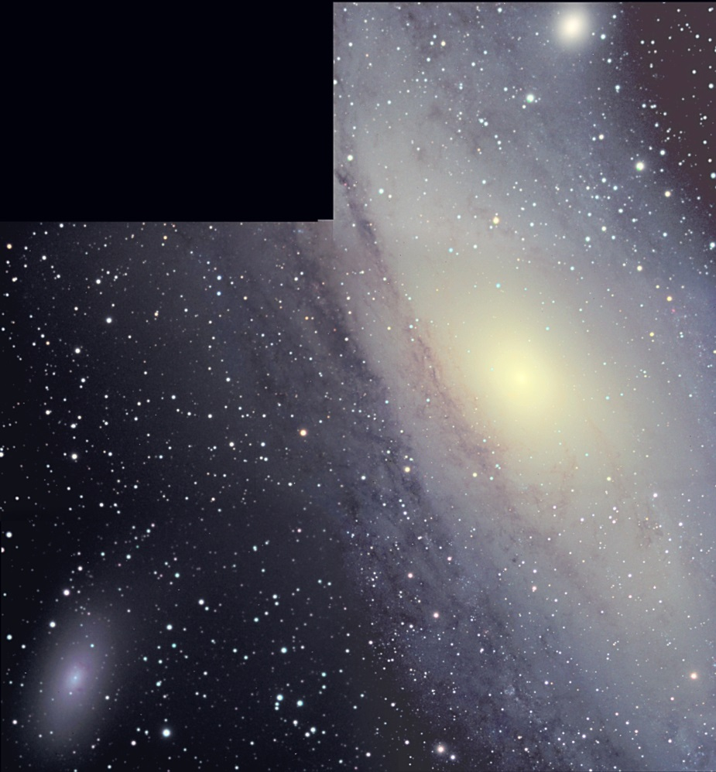

M31\_MosaicTestCroppedFiltered\_LVColBalBluep16A.jpg

## Appendices

### Jupiter Analysis 2009 Apparition

Last Updated 5/3/2015